Homework 3 ECE 5730/CIS5760 Due: 10-2-2022

- Watch theVideo: https://www.mathworks.com/videos/fpga-design-with-matlab-part-1-why-use-matlab-and-simulink-1569473289132.html
- Summarize what you learnt from the seminar in half page or more.

- Look at the figure below which is an Adder/ subtractor. Write a generic VHDL code to perform this function. The value of n-bit can be initialized to 8 or 16 at the beginning. But the program should use “n” to perform the computation.

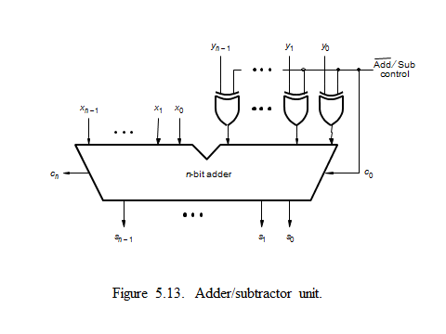

- For the latest Quartus II version available in our lab, write step by step guide/help for “schematic design entry method which allows the user to enter the project as a circuit diagram”. You can take screen shot for an example circuit that you try to enter into the project. Refer also to the tutorial in the Quartus II and also the one posted in the Moodle.

